**Games Development: Prototype Documentation**

**Game Overview & Origin**

***Concept***

***‘A first person 3D Platformer where you play the character in an unfinished game and must run, jump and grapple to collect the pieces needed to complete the game’***

DEFAULT is first person 3D platformer which features obstacles, hazards and item collection along with a focus on verticality with the use of a grappling hook. The main character is a place holder character in a newly created game project and is tasked in assisting its developer in the games creation this will included hunting down gear (i.e. grappling hook) and the ability to access further levels and change their appearance through the finding of various elements such as other objects and textures. The end result of which will be a more refined and overall better looking game with textures and additional objects (this will also help illustrate to the player the progress through the game)

The game is at its most basic a 3D platformer, meaning the key elements of the game will be traversing through each level collecting the required amount of items returning to the hub and progressing onto the next level.

***Story***

The story of DEFAULT is told through various videos that play through out each level from the developer making the game each level will contain one video which will show the developer having trouble with an aspect of the game through generic pseudo code.

**Mechanics and Gameplay**

The character ability at the start will be hindered due to the inability to use the grappling hook, their first task will be to acquire it through platforming over various platforms to help the player become better accustomed to the character speed and jump distance. DEFAULT has various obstacles that the player will have to avoid as to prevent them from being reset, this can include but not limited to swinging hammers and floating blocks.

Each level will all follow the same objective:

* Platform to the required items
* Return to the beginning of the level
* Return to hub to access next level

Along with this DEFAULT has a checkpoint system that allows the player progress to be persistent and allows for them to return to it at any time. Along with this to give the player the feeling that the world is being built around them some objects will be inaccessible or even invisible to the player, this means that when the player completes a level changes will be made to both the previous and next level allowing the player to directly see the progression of the game.

*Controls*

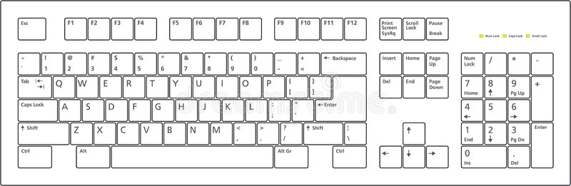

W = Forward

A = Left

S = Back

D = Right

F = Grapple

I = Menu

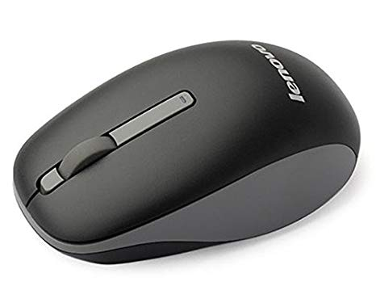

Mouse = Camera Control

**Game Engine**

Our team has decided to work with Unreal Engine 4 as the engine of choice.

This due mostly to Unreal Blueprint system allowing quicker (albeit simpler) implementation for systems required for our games. It also arguably can be easier to read (dependent on whether it has been organised cleanly) due to it having a more visual representation, along with this many functions. It also expandable through community plugins to include more functions one such plugin we used is the victory plugin that added various functions including reading and writing functions. Along with this the blueprints compiler will highlight functions that it finds error with making debugging quicker.

Along with this there is plenty of documentation for Unreal both officially from EPIC but from the community as well this helped in better understanding of the blueprint system that allowed for more complex systems to be implemented, due to the large community it also allows for a large breath of plugins from increased functions via blueprints to tools for animation etc. This can help overall development due to the amount of work that has already been done and is usually free to use.

There is also the unreal marketplace that allows for either the purchase or download of free assets that can be used to better improve the graphic fidelity of games this again can dramatically reduce development time due to the time saved needing to rig models and test them for any issues and clipping.

We chose Unreal over Unity as we have all had some experience with Unreal more than Unity and felt it would be a hassle to learn a new engine rather than use one we have some familiarity towards.

Overall the advantages of the unreal engine are, it’s easier to understand blueprint system, its extensive documentation and its community which all help dramatically reduce development time.

**Quality Assurance**

For the Quality assurance side of things Louis Graham handled that he started by taking a step back and looking at the levels and seeing straight away what could be added / removed or changed to make the level better, once the levels where altered to help improve the general gameplay he then moved onto a methodology people in the Quality Assurance industry use which is one of the main ones used and that’s Functionality Testing, he tested all of the main features like teleporting and the use of a grappling gun.

He documented all of his tests within a Test Table that he created with what would need tested before they were initially implemented, he also added and adapted / changed tests as the production of the levels progressed.

Model of the Test Table shown below.

**Art and Audio Production**

For the Audio Production section Louis Graham handled all of the sounds and effects.

He studied multiple other games for their techniques on how they handle and implement their own sounds for levels, he then went away and used a software called Audacity to record some of his own and to edit some other effects and / or sound clips that was taken from an online repository such as FreedsoundFx or FreeSoundGG.

He created and / or edited a lot of sound effects such as Female and Male footsteps, Female and Male Breathing, Female and Male Grunting, Female and Male Jumping as well as Portal Ambient Noises, Portal Teleporting sounds and multiple different Types of Door effects wither it be Opening and closing or creaking.

**Level Concept Design and Description**

Level Select Hub – We chose to have a Hub area where the player would be spawned in to select each level, this will be a generic level that has many hidden elements as the player travers through each level and collects the various pieces, geometry will change to included textures or entirely new sections by the end of the game this area should look radically different from the beginning to help visualise the players progress throughout the game.

First Level – This level will focus on horizontal movement as the player will have to reach grappling hook, out of the levels this one will be very basic to help player understand how far they can jump and make the overall experience easier in the long run.

Second Level - Description

Third Level - Description

Fourth Level - Description

Fifth Level – Description

**Game Design Approach…**

This game’s level Design approach is based on a Linear Level Design. One of the reasons of doing this is because of the rules in the Game are pre-defined in in a way that requires the player to reach the fifth and final Level by completing each level chronologically from the First Level onwards. This Rule on its own creates the linear format for the player to follow as the Game cannot and will not progress without these steps taken.

Another reason of choosing this Approach is that it’s easier to create a Game in which the path to victory is already pre-determined for the player to get to. The only problem this causes is the restriction that the player may feel because of the lack of personal decision making based off of where they can go and when they go to it.

The Linear design can be seen on this Flow chart down below:



**Error/Problem Log**